# Task 2

1. Create Employees and Projects tables with the following constraint:

(E_fname ,E_salary,P_name must be entered from user, E_salary must be greater than 2500, p_hours must be greater than 25).

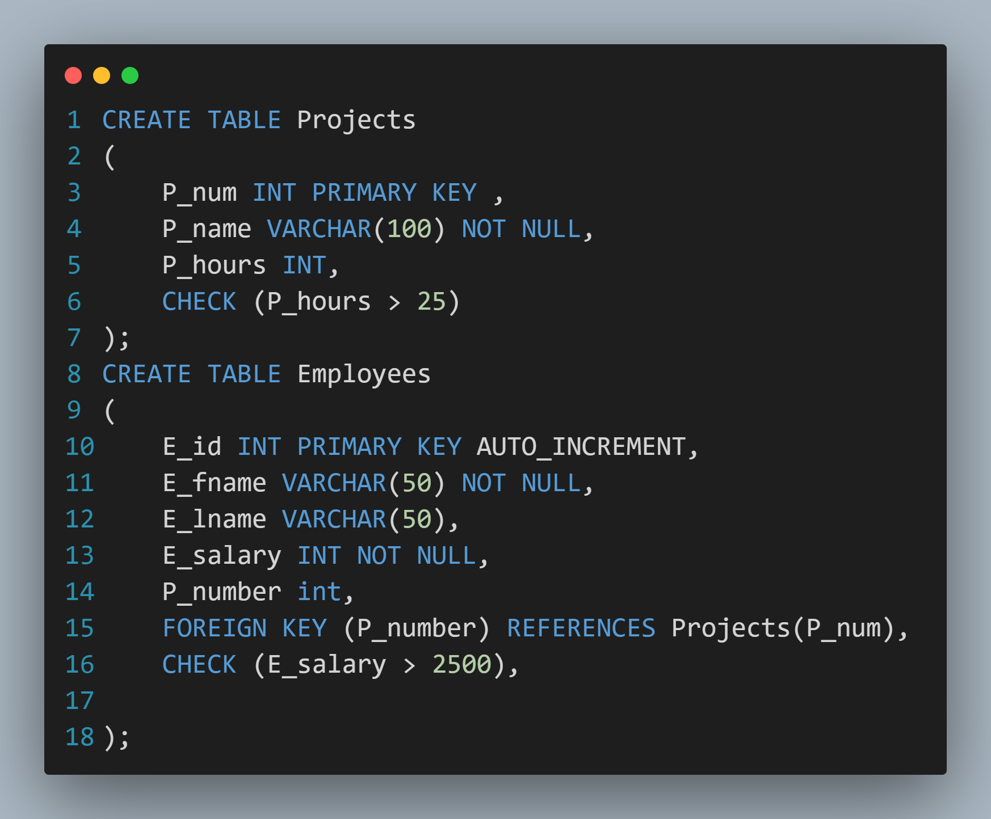

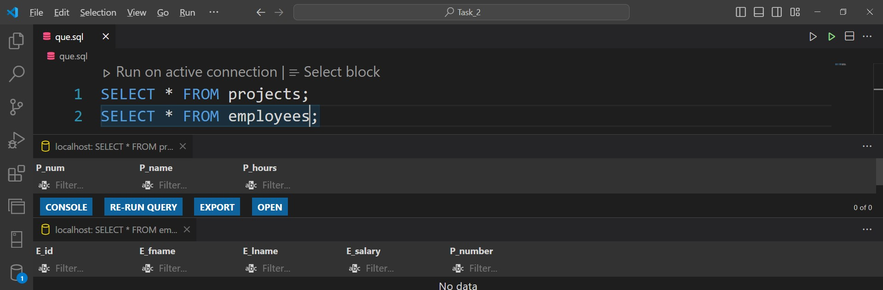

1. Add E_address column to employee table that must be only cairo, giza, and helwan,

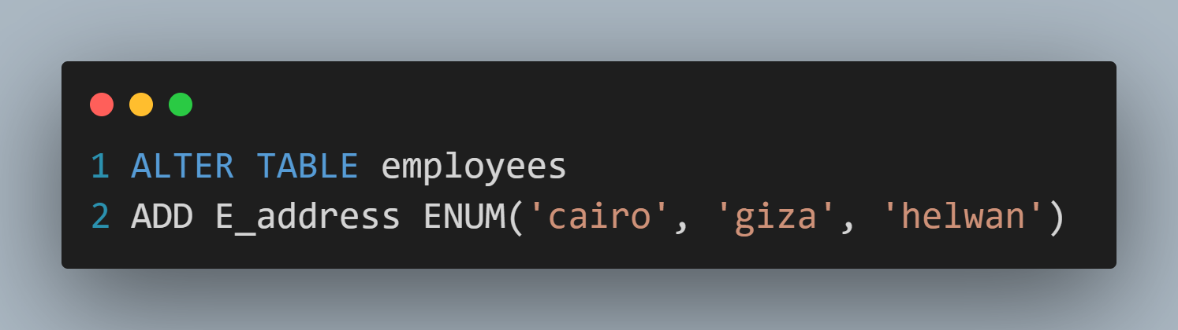

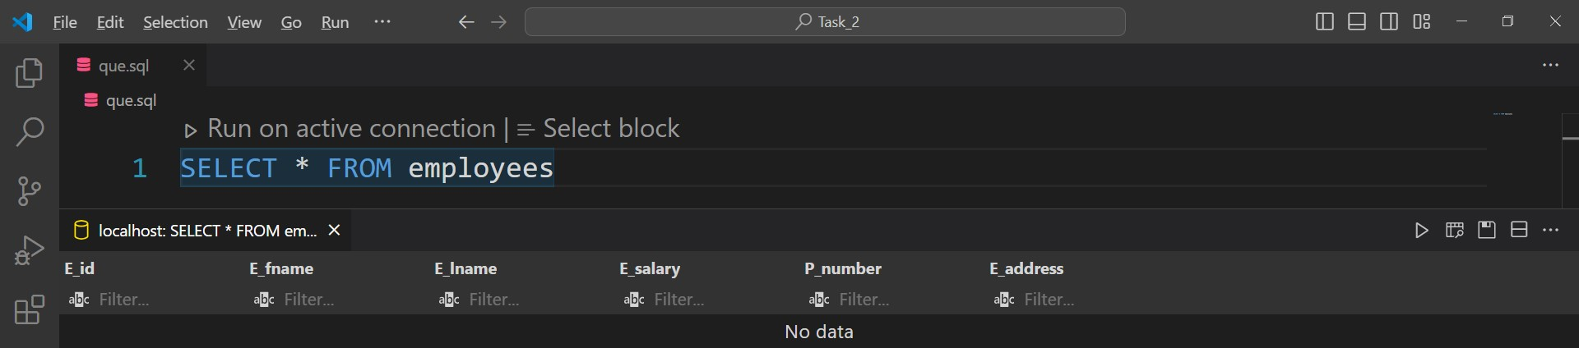

1. Insert values into two tables.

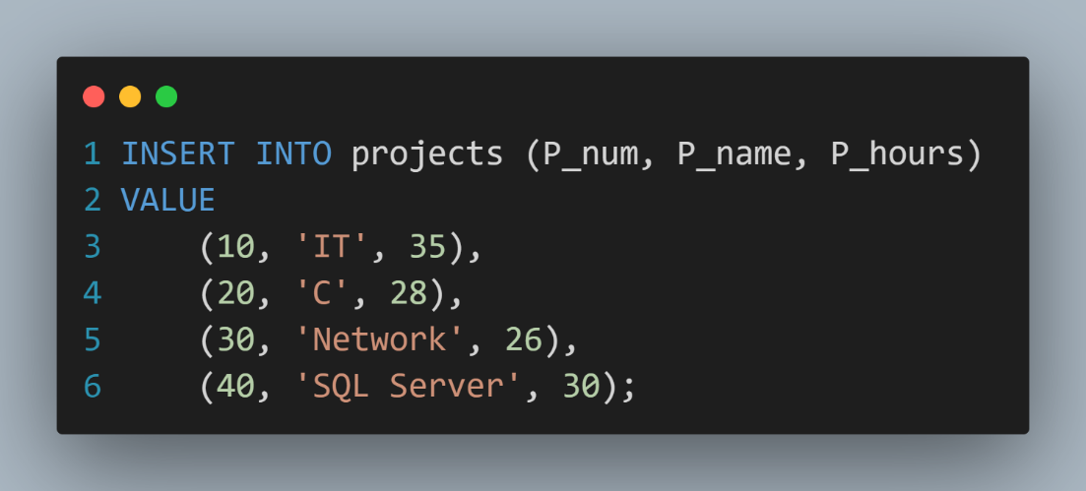

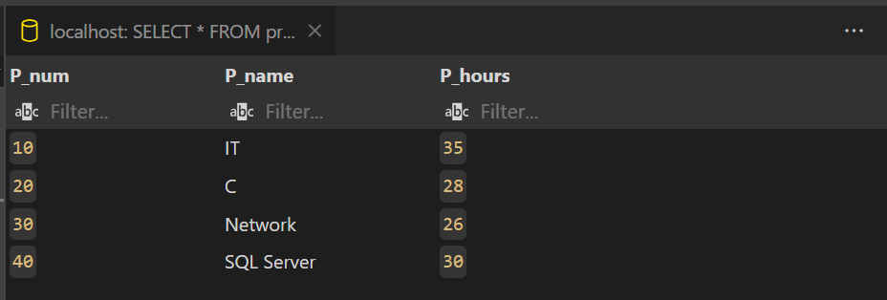

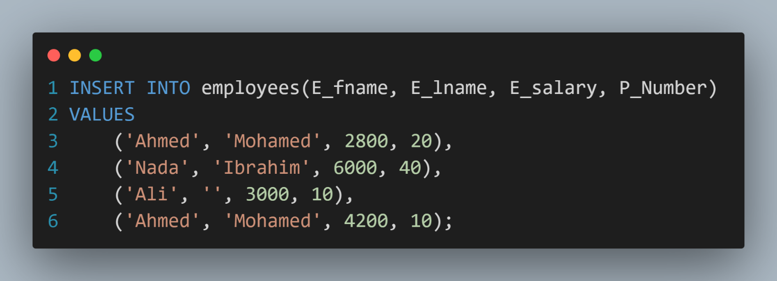

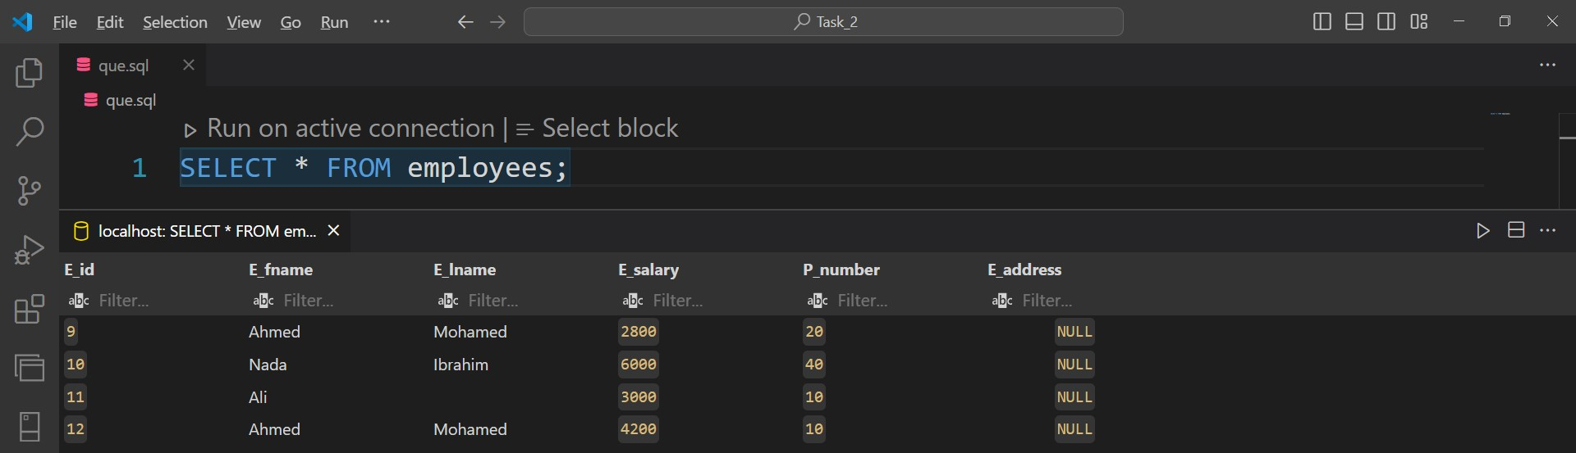

1. Select Project name start with N.

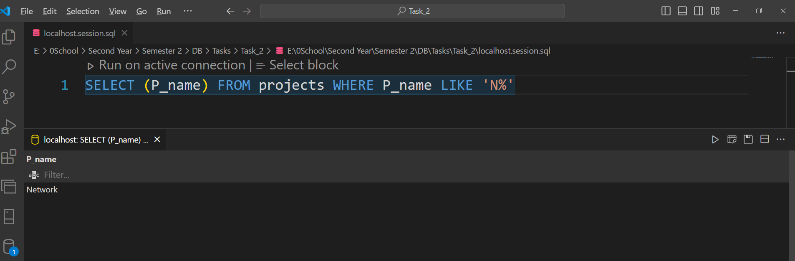

1. Select employee salary from 3000 to 6000.

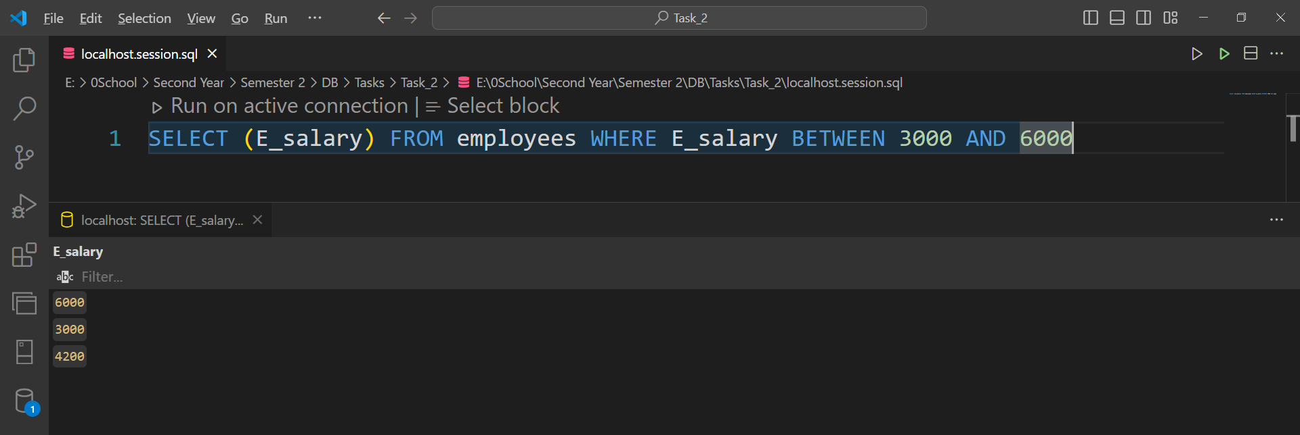

1. Select number of Employees without repeated name.

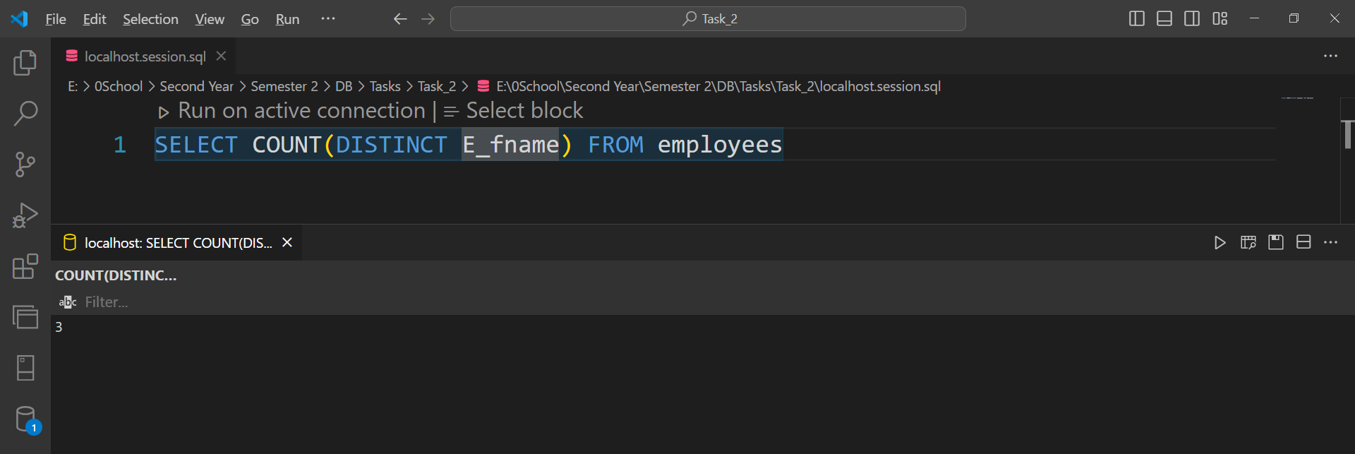

1. Set P_name = IOT with Project number 30.

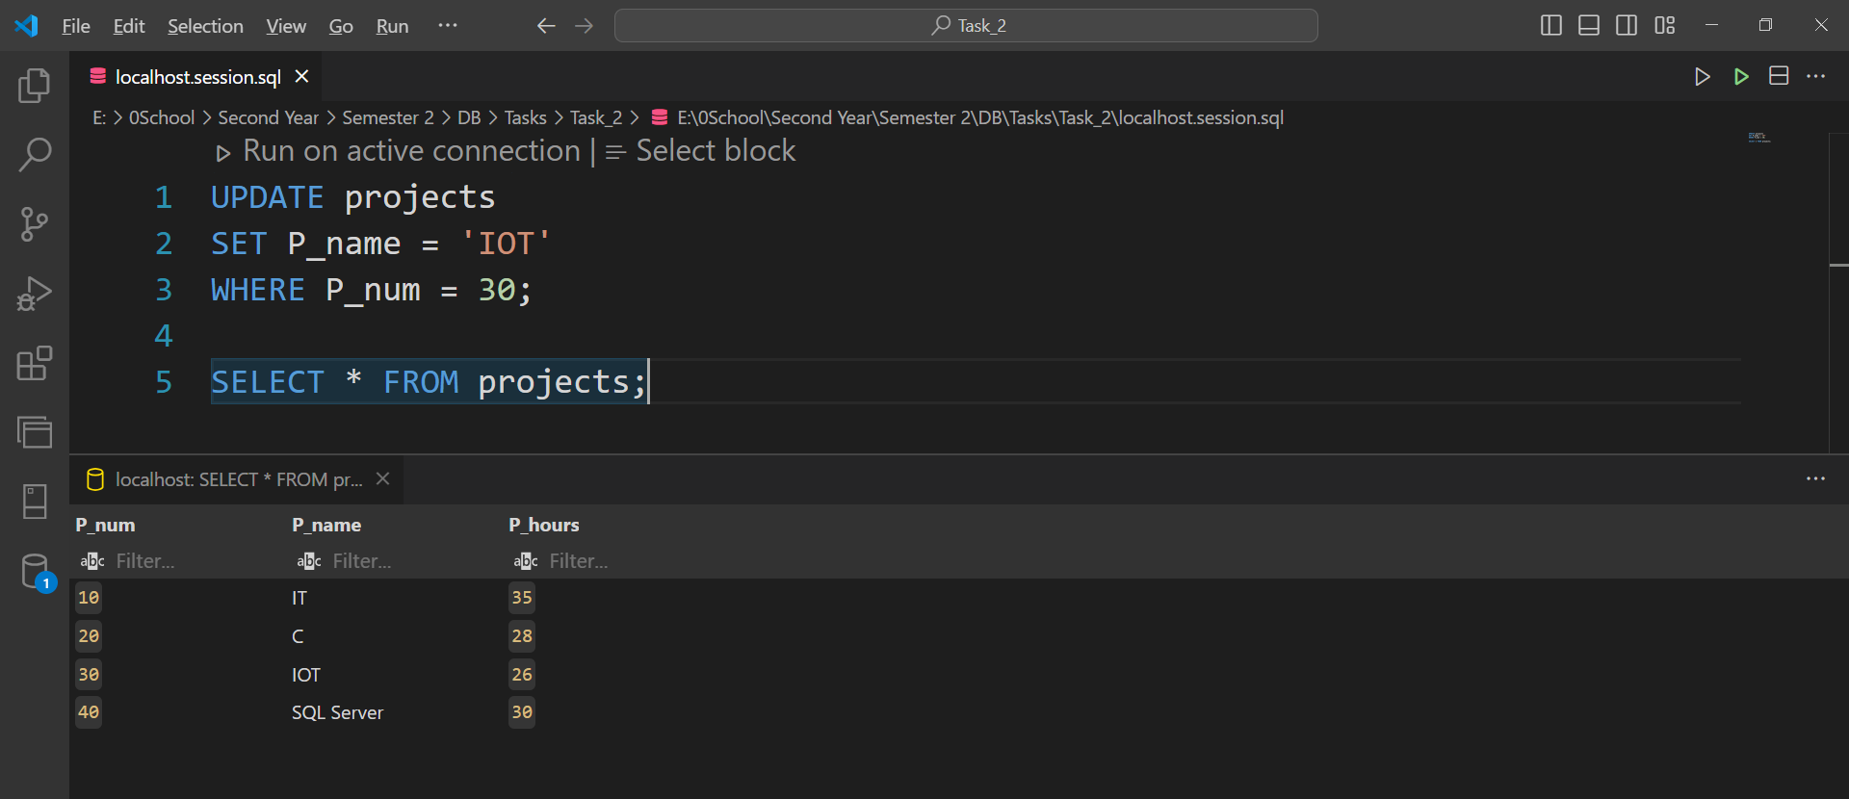

1. Select full name of employees sorting then descending.

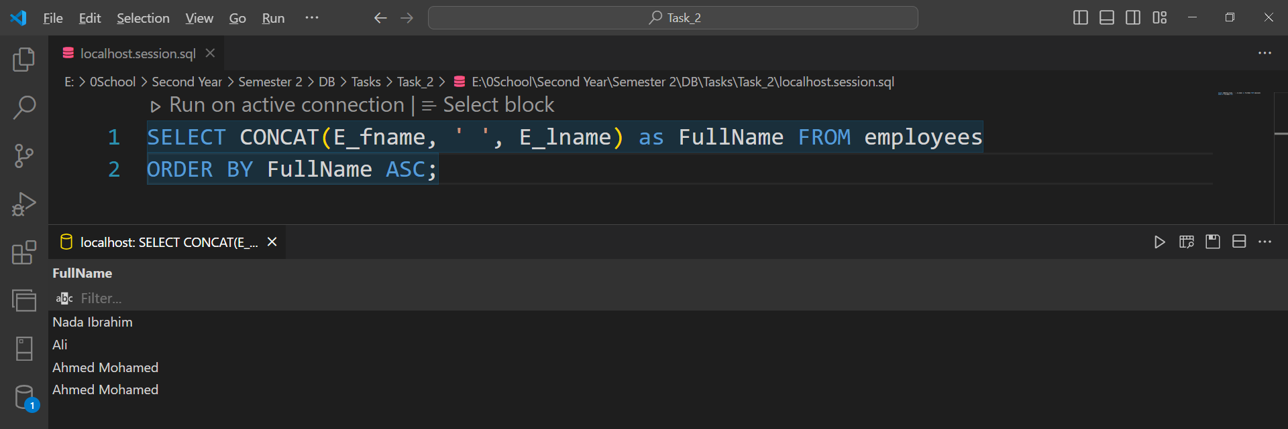

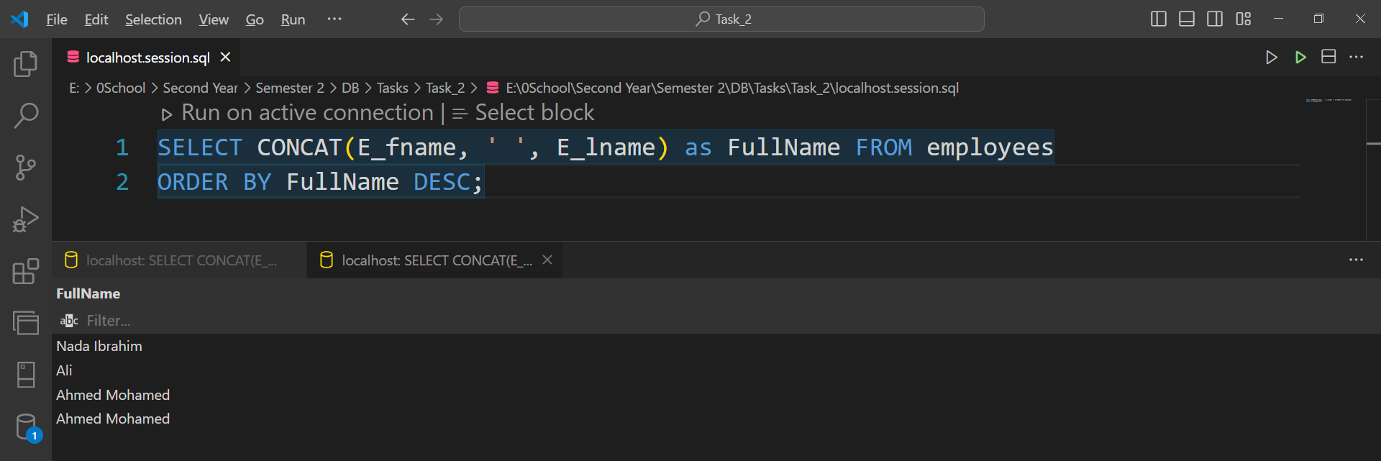

1. Select P_name of maximum hours and E_name that works on it.

